**HDR Image Processing Report**

### **Abstract**

This project focuses on developing a pipeline for High Dynamic Range (HDR) imaging, which enhances the quality of images taken with different exposure levels. HDR imaging combines multiple images with varying exposure settings to produce a single image that captures a wider range of brightness, from the darkest shadows to the brightest highlights. This project uses a set of three images with different exposures, merged into a single HDR image using advanced HDR merging techniques.

The pipeline consists of the following components:

* **HDR Merging:** The images are merged using one of three methods: Debevec, Robertson, and Mertens Fusion. These methods are designed to maximize details in both highlight and shadow regions of the scene.
* **Tone Mapping:** The resulting HDR image has a broader brightness range than a standard 8-bit image can display. Tone mapping techniques, such as Reinhard, Drago, and Mantiuk, are applied to compress the dynamic range while preserving detail in both dark and bright regions.
* **Evaluation Metrics:** The quality of the HDR image is assessed using two key metrics: Dynamic Range and Contrast-to-Noise Ratio (CNR). These metrics evaluate the image's retained brightness levels and clarity in dark areas.

The solution, implemented using OpenCV, NumPy, and Streamlit, enables users to experiment with different HDR merging and tone mapping methods and evaluate the results. The system is designed to be user-friendly, allowing users to explore HDR image processing with minimal technical knowledge.

### **Introduction**

High Dynamic Range (HDR) imaging aims to overcome the limitations of standard imaging technologies by capturing a broader range of brightness levels, from dark shadows to bright highlights. Traditional Low Dynamic Range (LDR) images cannot fully represent scenes with both very bright and dark regions, leading to loss of detail. HDR merges multiple images taken at different exposures, capturing the full dynamic range of a scene.

HDR imaging is increasingly popular in photography, cinematography, and gaming for producing more realistic and detailed images. It is especially useful for scenes with high contrast, such as landscapes, architectural photography, and night scenes.

### **How HDR Works**

HDR imaging involves the following steps:

* **Capturing Multiple Exposures:** A series of images are taken at different exposure levels: one underexposed (for highlights), one properly exposed, and one overexposed (for shadows).
* **Merging Images into HDR:** The images are combined using HDR merging techniques to preserve details in shadows, mid-tones, and highlights.
* **Tone Mapping:** HDR images have a wide range of intensity values, which cannot be directly displayed on standard screens. Tone mapping compresses the dynamic range into a format suitable for regular monitors while retaining detail in both dark and bright regions.

### **The Problem**

Despite its potential, HDR faces challenges:

* **Merging Exposures:** Merging multiple images requires sophisticated algorithms to align them and correctly combine pixel values from different exposures.
* **Tone Mapping:** Converting HDR images into a standard displayable format without losing detail is complex.
* **Image Quality Evaluation:** With multiple techniques for HDR merging and tone mapping, it is essential to evaluate which methods produce the best results.

### **Project Objective**

The objective of this project is to implement an HDR image processing pipeline that:

* **Merges Multiple Exposure Images:** Combines three LDR images with varying exposure values into one HDR image, capturing both highlights and shadows accurately.
* **Applies Tone Mapping:** Converts the HDR image into an 8-bit displayable image, retaining as much detail as possible.
* **Evaluates the HDR Image:** Uses Dynamic Range and Contrast-to-Noise Ratio (CNR) metrics to assess the quality of the final HDR image.

### **Key Components of the Project**

* **HDR Merging:** Implements three HDR merging algorithms—Debevec, Robertson, and Mertens Fusion—to combine multiple LDR images into a single HDR image.
* **Tone Mapping:** Applies three tone mapping techniques—Reinhard, Drago, and Mantiuk—to compress the HDR image into a format suitable for display.
* **Evaluation Metrics:**
  + **Dynamic Range:** Measures the difference between the lightest and darkest pixel values, indicating the preservation of brightness details.
  + **Contrast-to-Noise Ratio (CNR):** Evaluates the contrast between regions of the image and the noise in dark regions, ensuring clarity and detail retention.

### 

### 

### **Methodology**

The HDR image processing pipeline consists of the following steps:

#### **1. Image Upload**

Users upload three images with different exposure values. The images must have:

* Different exposure levels (underexposed, properly exposed, overexposed).
* The same resolution for proper alignment during merging.

#### **2. HDR Merging**

After image validation, the following merging techniques are applied:

* **Debevec:** Uses a weighted average of pixel values from different exposures to preserve both highlight and shadow details.
* **Robertson:** A robust method that adjusts for varied exposure levels and minimizes ghosting or artifacts.
* **Mertens Fusion:** Merges images based on pixel intensities, used primarily for tone mapping without creating an intermediate HDR image.

#### **3. Tone Mapping**

The HDR image undergoes tone mapping to compress its dynamic range for display on standard monitors. Three tone mapping techniques are used:

* **Reinhard:** Compresses the dynamic range while maintaining contrast and preserving details in both bright and dark regions.
* **Drago:** Designed for high-contrast scenes, it ensures that details in both dark and bright regions are preserved.
* **Mantiuk:** Enhances local contrast and compresses the dynamic range for natural-looking results, ideal for outdoor scenes.

#### **4. Evaluation Metrics**

* **Dynamic Range:** Measures the range of pixel intensities to ensure the image retains both bright and dark details.
* **Contrast-to-Noise Ratio (CNR):** Measures the visibility of details in dark regions relative to noise, ensuring clarity and minimal noise.

### **Results**

The HDR image was processed using different combinations of HDR merging techniques and tone mapping methods. Each combination produces a unique output based on how the merging and tone mapping interact. The results include the **Dynamic Range** and **Contrast-to-Noise Ratio (CNR)**, which provide insight into the quality of the final HDR image.

#### **4.1. Dynamic Range**

The **Dynamic Range** is an essential metric for evaluating the effectiveness of the HDR processing. It measures the range of pixel intensity values in the final HDR image, reflecting the image’s ability to retain both bright and dark details. A higher dynamic range indicates that more detail has been preserved across the light and dark areas of the image.

For each combination of merging and tone mapping, the **maximum and minimum pixel values** are computed from the processed HDR image, and these values are displayed to provide insight into how well the HDR merging preserved the scene's dynamic range.

#### **4.2. Contrast-to-Noise Ratio (CNR)**

The **Contrast-to-Noise Ratio (CNR)** is calculated between two selected regions of interest (ROIs)—one in a bright region and one in a dark region. This metric is useful for evaluating how well the processed image maintains detail in the darker areas of the image, where noise is most likely to appear after tone mapping. A higher CNR value indicates better contrast and detail visibility in the darker regions.

For each combination of merging and tone mapping, the CNR value is computed and displayed.

#### **4.3 Sample Inputs**

By adjusting the **exposure values** based on the mobile settings you can use these three images.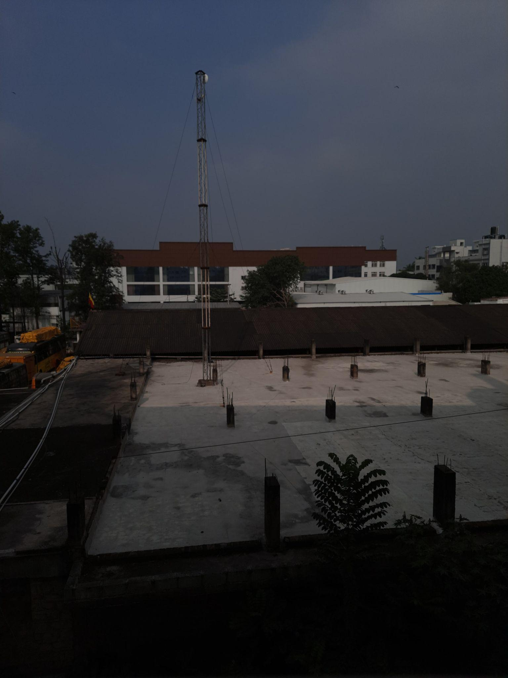

**Underexposed Image**: Use a **lower exposure value** (around **-2 to -3 EV**).

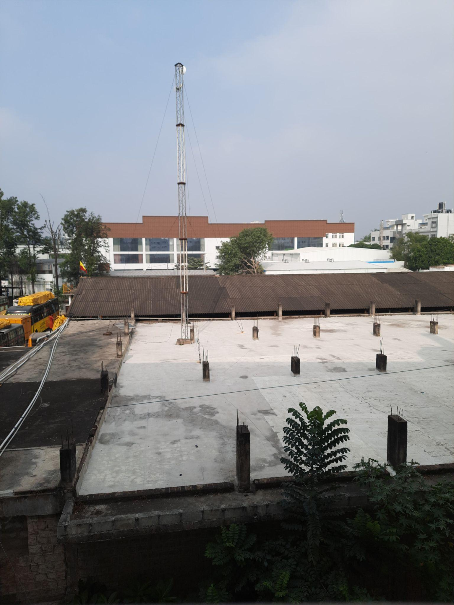

**Correctly Exposed Image**: Use an **exposure value of 0 EV**.

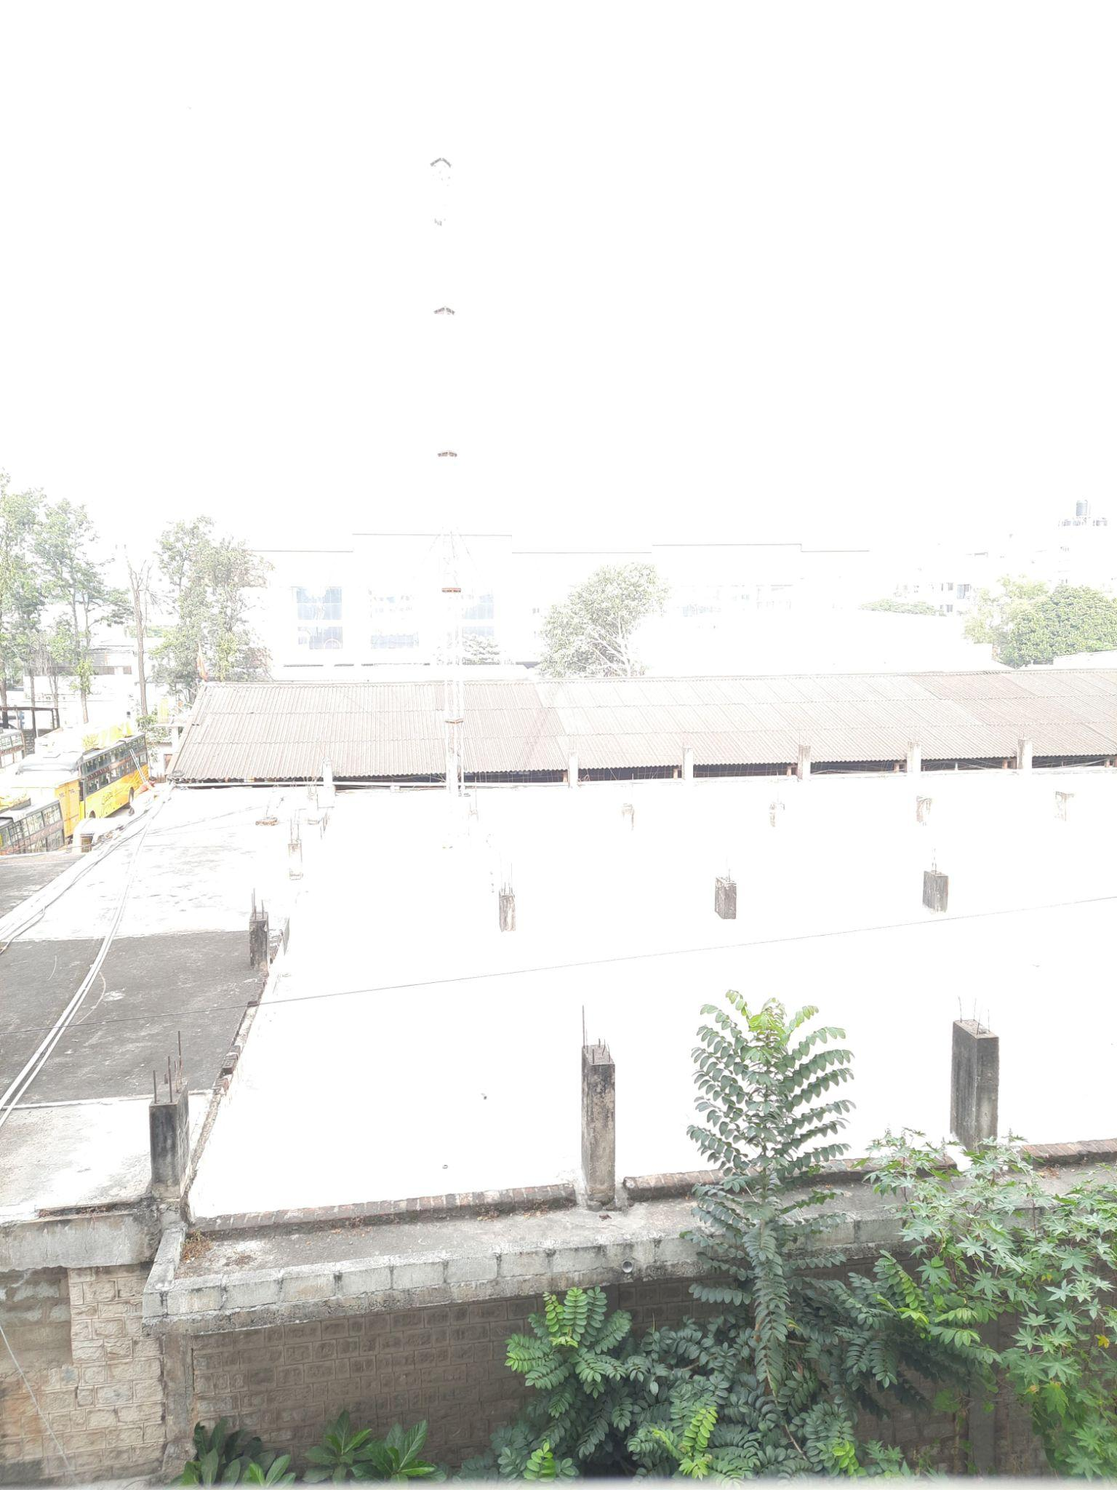

**Overexposed Image: Use a higher exposure value (around +2 to +3 EV).**

#### **4.4. Sample Output**

For each combination of **HDR Merging** and **Tone Mapping**, the following results are presented:

* **Processed HDR Image**: The final HDR image after merging and tone mapping.
* **Dynamic Range**: The maximum and minimum pixel values in the final HDR image, which reflect the preserved intensity range.
* **CNR**: The calculated contrast-to-noise ratio between the bright and dark regions of the final image.

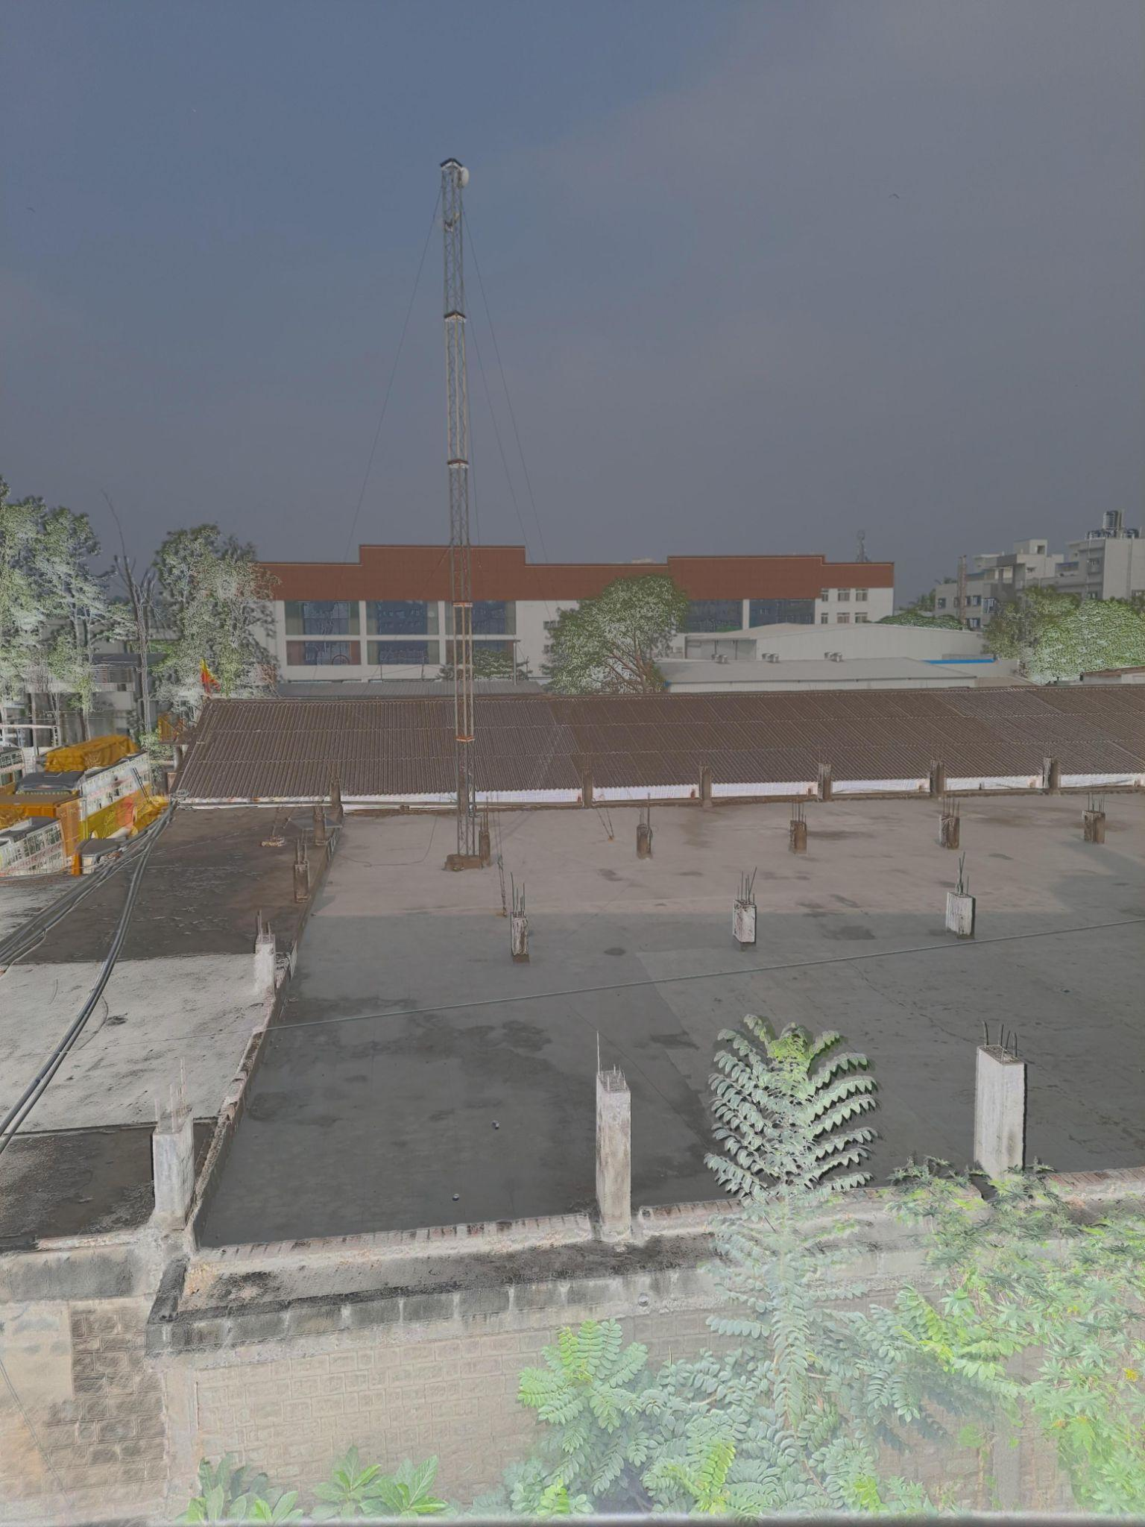

**Debevec with Reinhard**

Dynamic Range of HDR Image:

Max = 255.0,

Min = 0.0

Contrast-to-Noise Ratio (CNR) of HDR Image: 0.018594574321219293

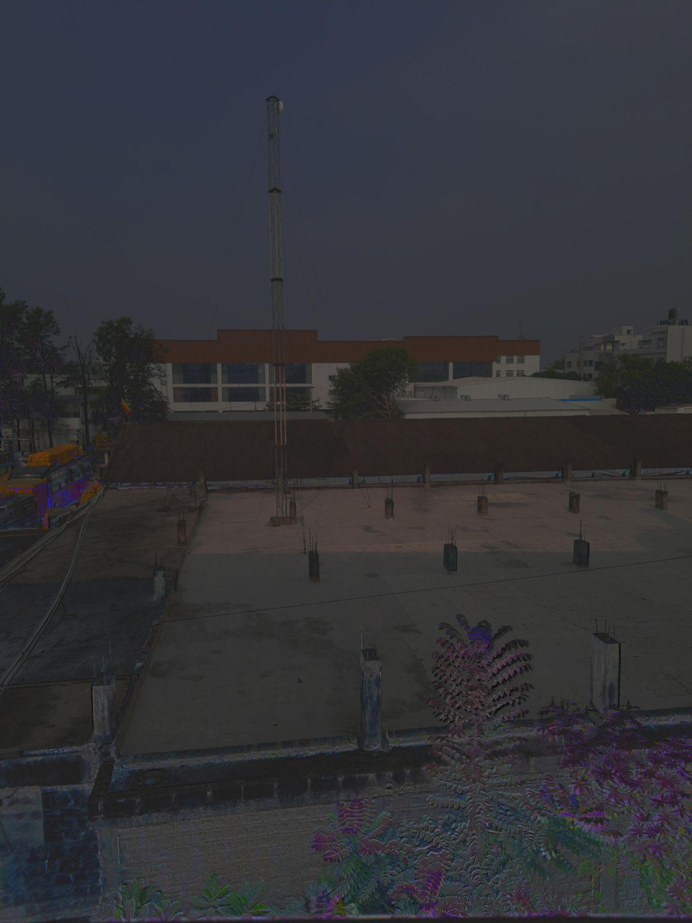

**Robertson with Reinhard**

Dynamic Range of HDR Image:

Max = 255.0, Min = 0.0 Contrast-to-Noise Ratio (CNR) of HDR Image: 0.0029108320916349795

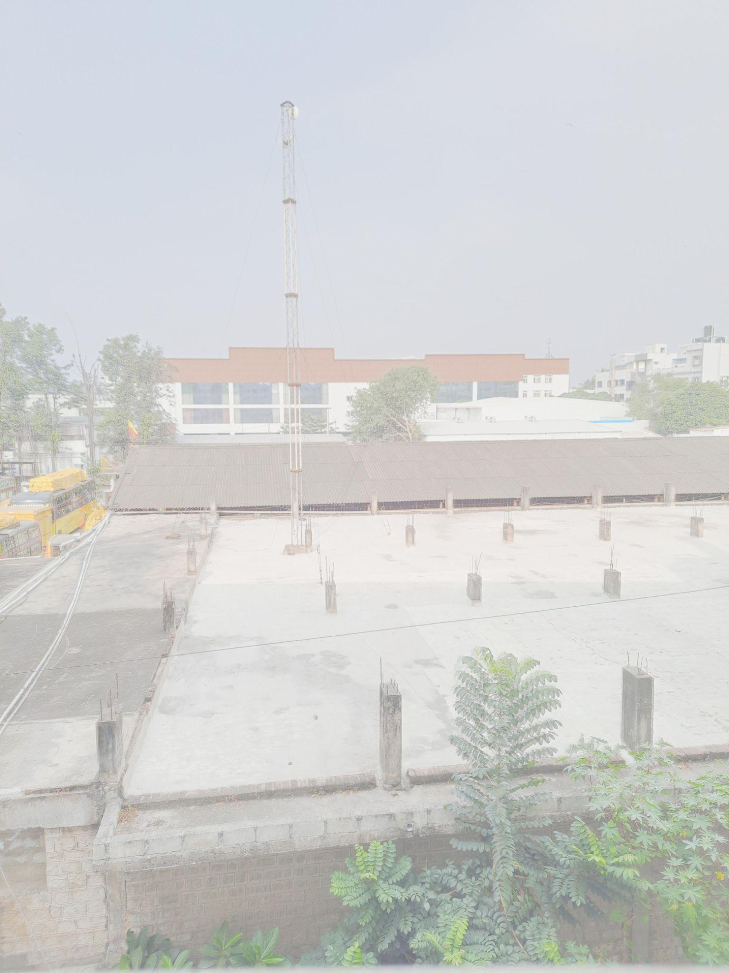

**Mertens Fusion (No HDR) with Reinhard**

Dynamic Range of HDR Image:

Max = 255.0, Min = 0.0

Contrast-to-Noise Ratio (CNR) of HDR Image: 0.0026798836425187505

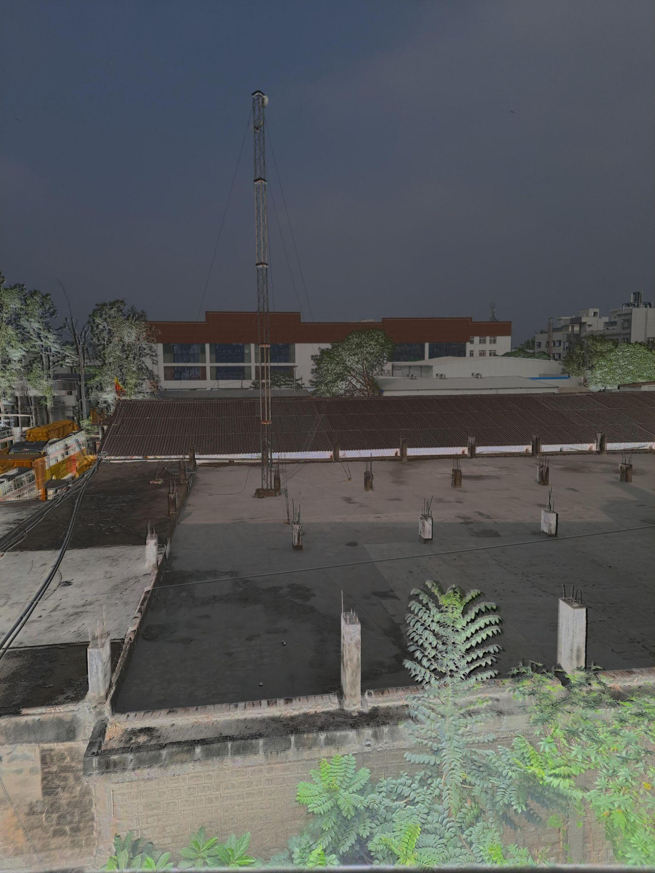

**Debevec with Drago**

Dynamic Range of HDR Image:

Max = 255.0, Min = 0.0

Contrast-to-Noise Ratio (CNR) of HDR Image: 0.01704467443865896

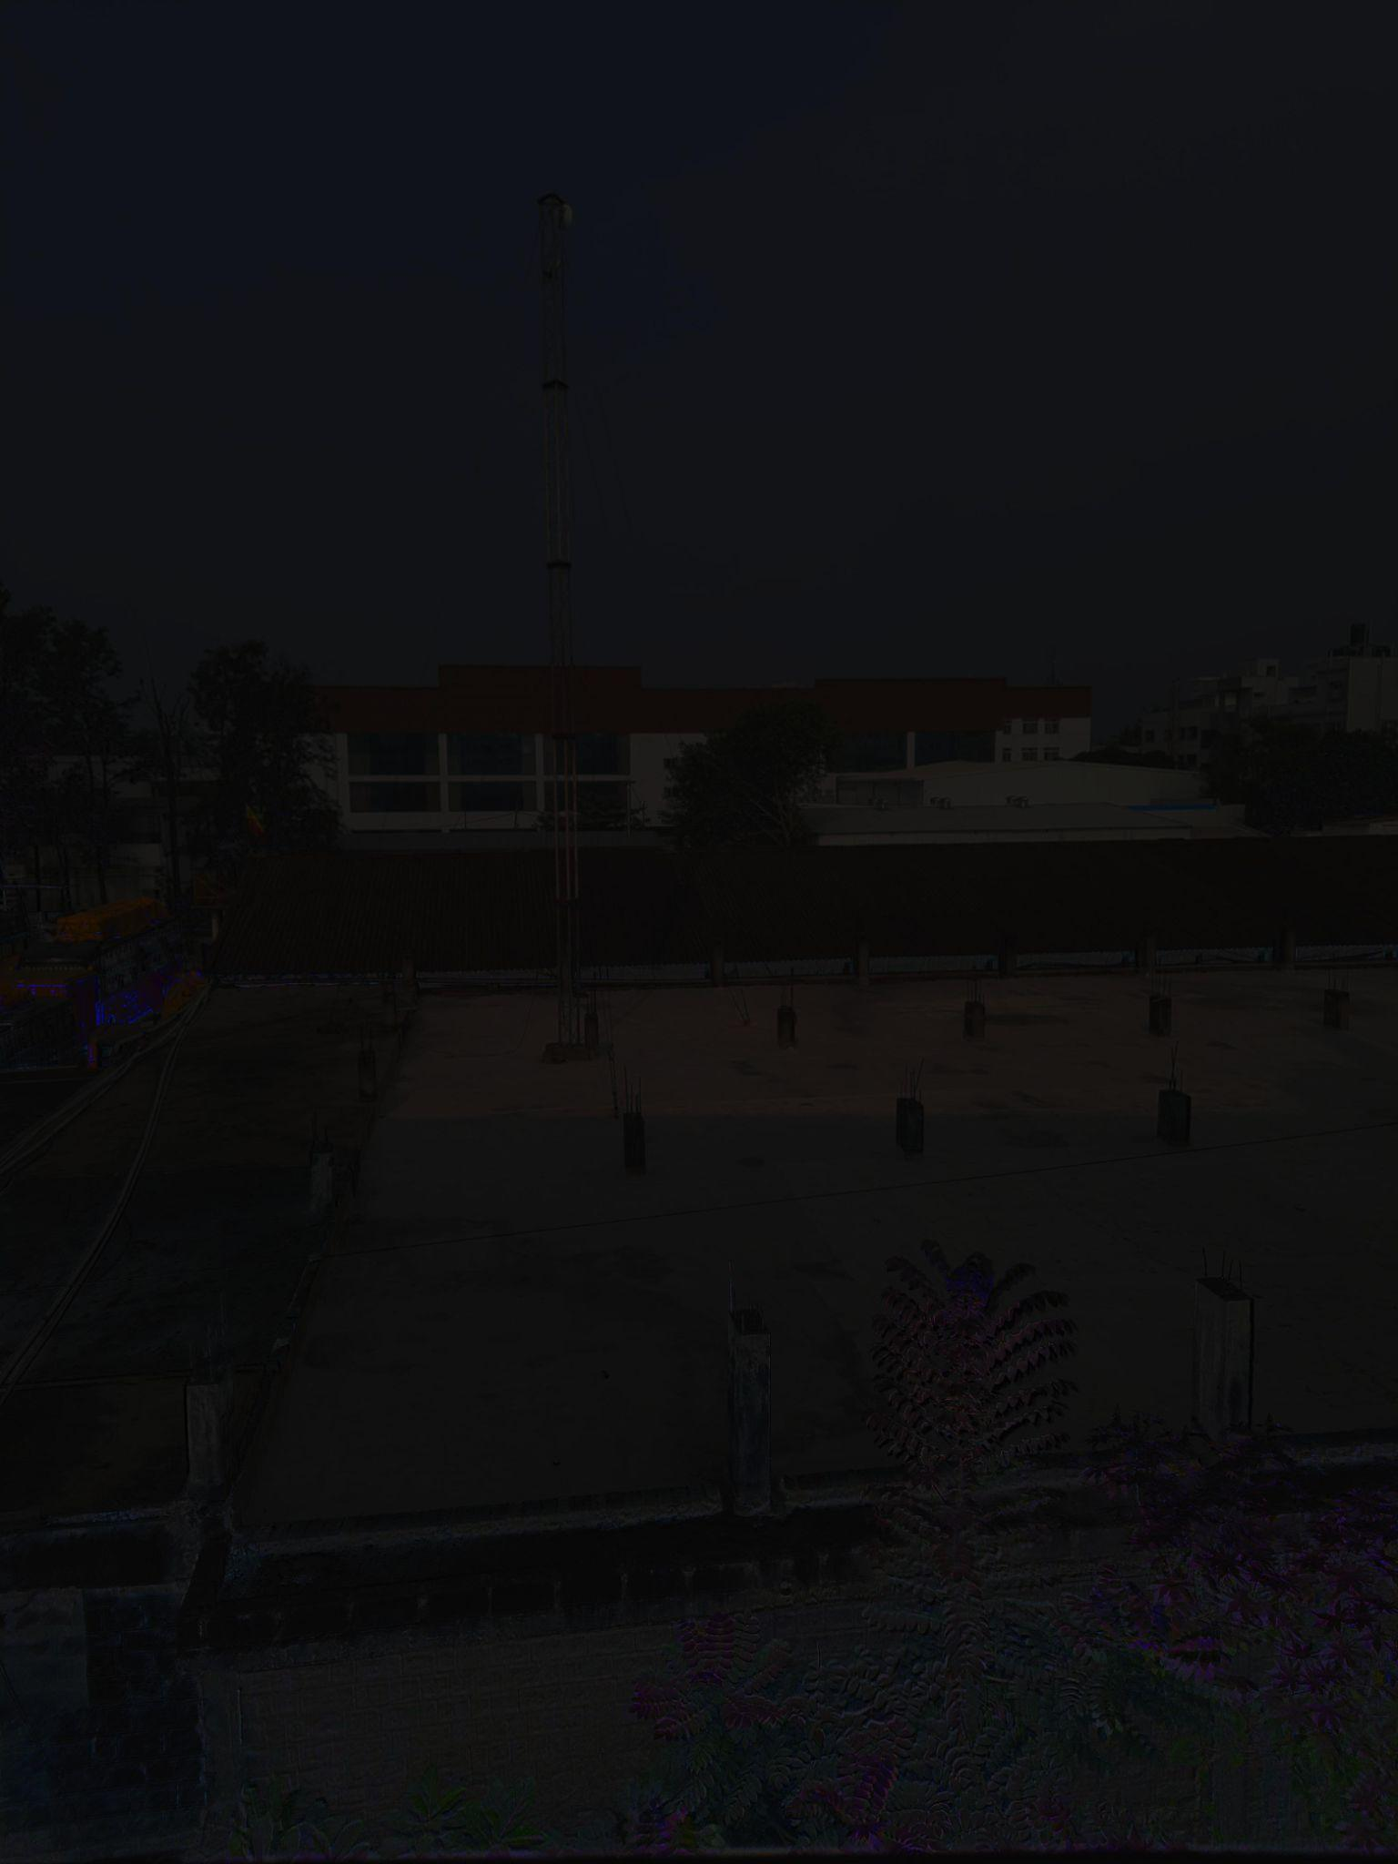

**Robertson with Drago**

Dynamic Range of HDR Image:

Max = 255.0, Min = 0.0

Contrast-to-Noise Ratio (CNR) of HDR Image: 0.008584312791493616

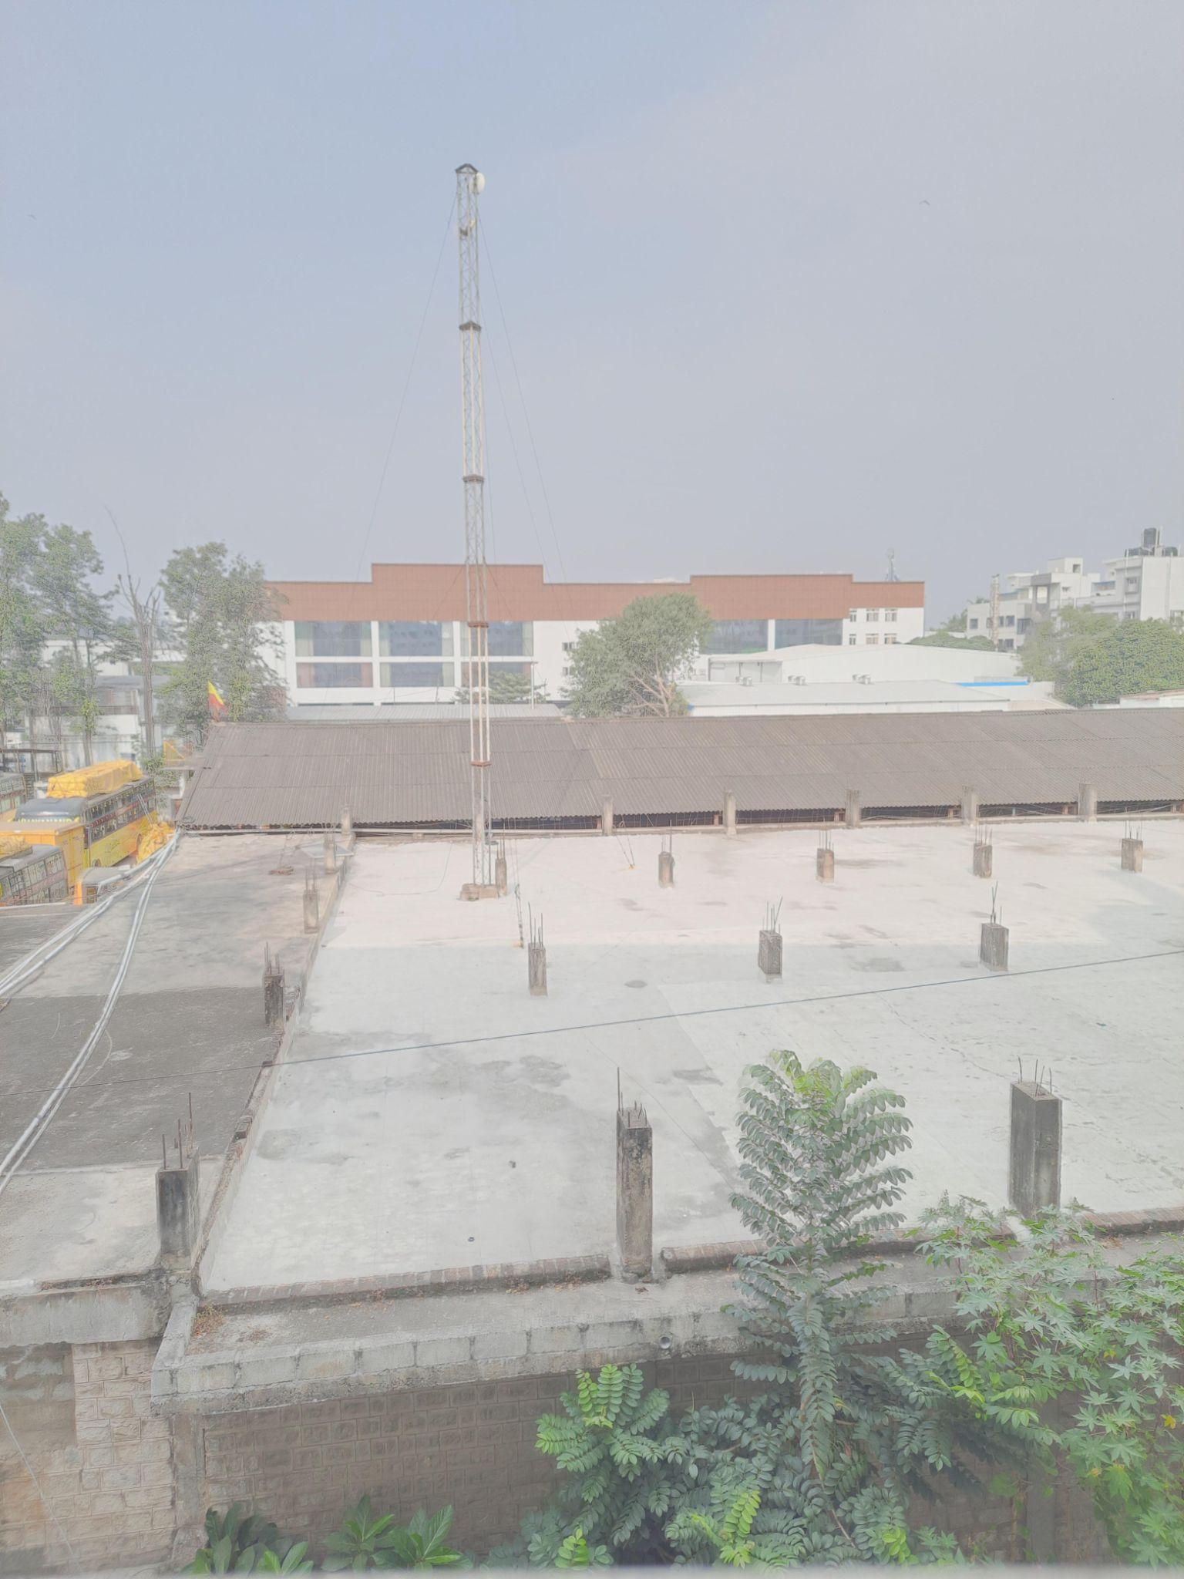

**Mertens Fusion (No HDR) with Drago**

Dynamic Range of HDR Image:

Max = 255.0, Min = 0.0

Contrast-to-Noise Ratio (CNR) of HDR Image: 0.005213102566997122

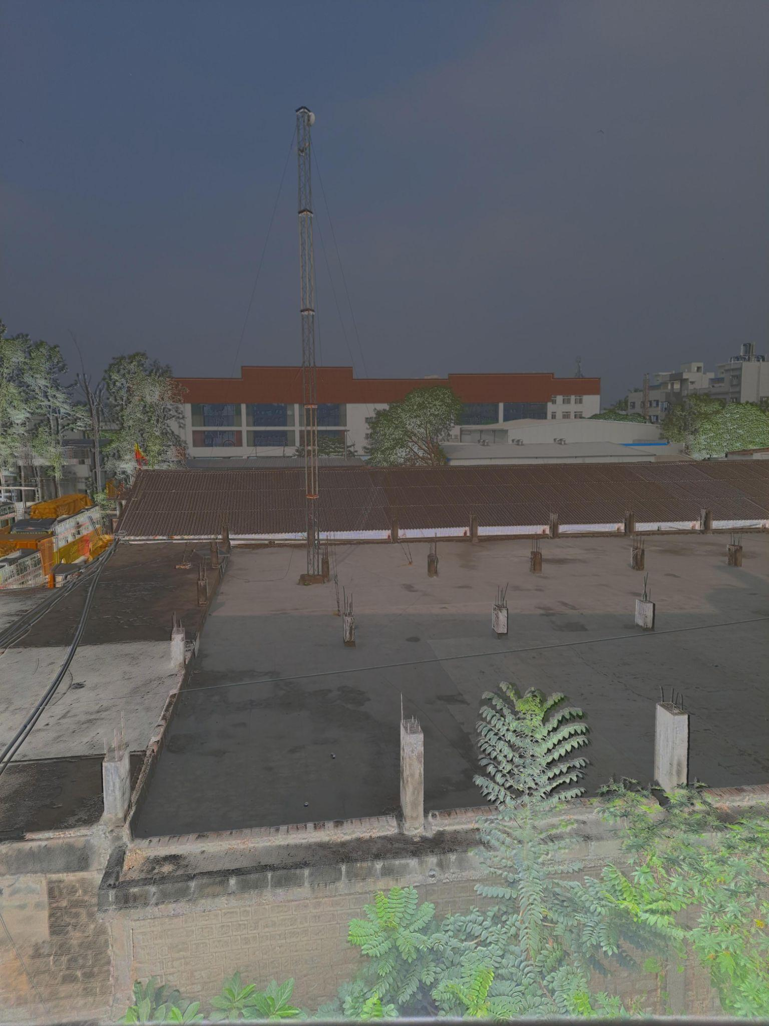

**Debevec with Mantiuk**

Dynamic Range of HDR Image:

Max = 255.0, Min = 0.0

Contrast-to-Noise Ratio (CNR) of HDR Image: 0.011478075498097824

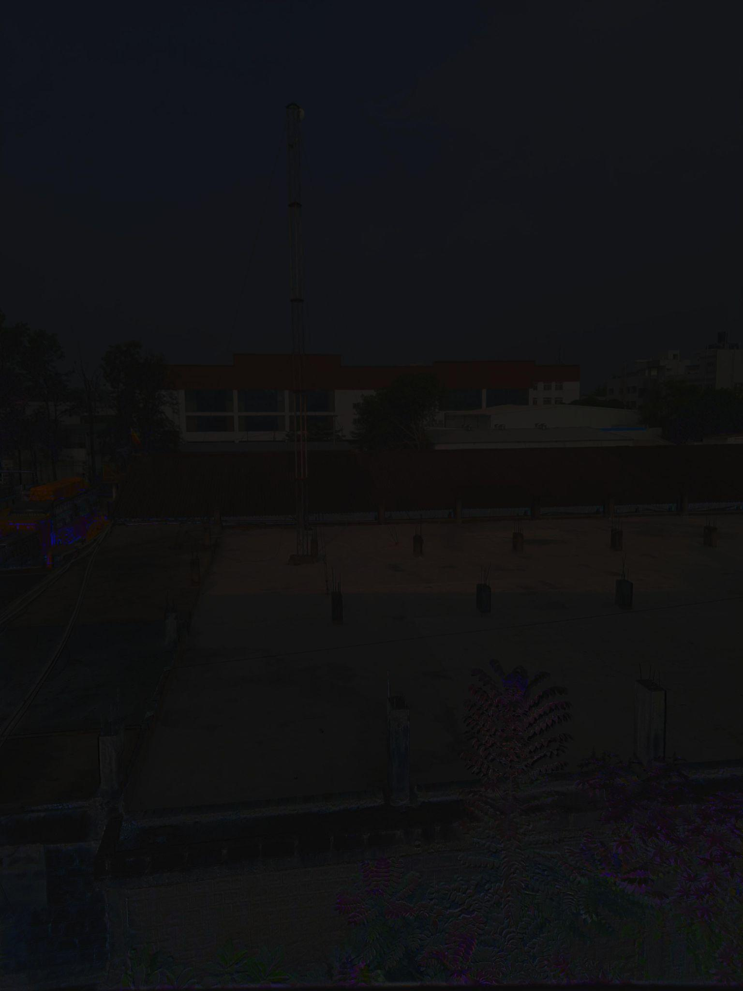

**Robertson with Mantiuk**

Dynamic Range of HDR Image:

Max = 255.0, Min = 0.0

Contrast-to-Noise Ratio (CNR) of HDR Image: 0.08324288482061404

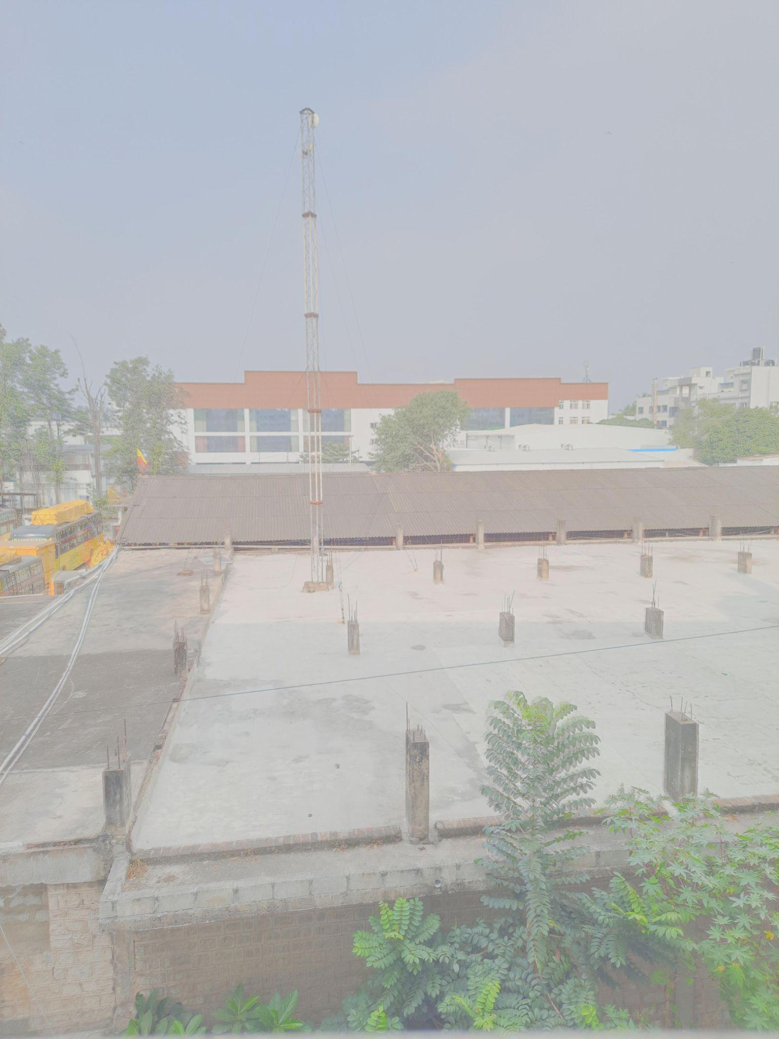

**Mertens Fusion (No HDR) with Mantiuk**

Dynamic Range of HDR Image:

Max = 255.0, Min = 0.0

Contrast-to-Noise Ratio (CNR) of HDR Image: 0.0005907443942340494

### **Summary:**

1. **Dynamic Range:** All combinations preserved the full dynamic range (0.0–255.0).
2. **Best Performer (Overall CNR):**
   * **Robertson with Mantiuk** had the highest CNR (0.08320.08320.0832), indicating excellent contrast preservation with minimal noise.
3. **Worst Performer:**
   * **Mertens Fusion (No HDR) with Mantiuk** had the lowest CNR (0.00060.00060.0006), highlighting high noise and poor contrast-to-noise balance.
4. **Tone Mapping Comparisons:**
   * **Mantiuk** generally outperformed Reinhard and Drago in terms of CNR.
   * **Reinhard** provided slightly better results compared to Drago for some combinations.
5. **HDR Merging Methods:**
   * **Debevec** and **Robertson** showed superior performance compared to **Mertens Fusion (No HDR)**, emphasizing the importance of HDR merging in achieving better results.

### **Recommendations:**

* Use **Robertson with Mantiuk** for applications requiring high contrast and low noise.
* Avoid **Mertens Fusion (No HDR)**, especially with Mantiuk, as it fails to achieve good CNR.
* Select tone mapping operators based on specific requirements (e.g., Mantiuk for contrast, Reinhard for balance).